E-COMMERCE CUSTOMER PURCHASE ANALYSIS
Project Report
Name: Arnav Jena
Roll Number: 23051088
Batch: BTech CSE

1. PROBLEM STATEMENT
An online e-commerce platform manages a large dataset of customer purchases containing critical information about transactions, customer details, and product interactions. The marketing department requires a comprehensive analysis of this purchasing behavior to optimize promotional campaigns and identify high-value customers. The organization needs data-driven insights to answer pivotal business questions such as: Which customers generate the highest revenue? Which products are most frequently purchased? Which geographic regions contribute the most to overall sales? Without systematic analysis, marketing resources are allocated inefficiently, leading to missed opportunities for revenue optimization and customer retention.
2. SOLUTION AND FEATURES
2.1 SQL Analytics Module
Implemented comprehensive SQL queries to extract actionable insights from relational databases. Features include: (a) Purchase record retrieval with complete transaction details; (b) Customer lifetime value calculation showing total spending per customer; (c) Product popularity ranking by frequency of purchase; (d) Geographic revenue analysis with city-wise sales aggregation. These queries enable rapid identification of top-performing customers and products for targeted marketing campaigns.
2.2 Excel Data Processing
Leveraged Excel to build a comprehensive analytical framework including: (a) Dynamic computed columns for total purchase value (quantity × price); (b) Multi-dimensional pivot tables analyzing product sales patterns; (c) City-wise revenue distribution tables for geographic market analysis; (d) Conditional formatting and summary statistics for quick visual pattern recognition. Excel dashboards provide business stakeholders with intuitive, updatable analytical tools.
2.3 Python Data Analysis
Implemented Python scripts using pandas, numpy, and matplotlib libraries to: (a) Load and preprocess CSV datasets; (b) Calculate derived metrics like total_purchase values; (c) Identify top 5 customers by spending using groupby and sort operations; (d) Analyze product popularity through frequency analysis and ranking. Python automation enables reproducible, scalable analysis applicable to larger datasets.
2.4 Interactive Visualizations
Created publication-ready visualizations: (a) Bar charts displaying product sales performance with descending order ranking; (b) Pie charts showing city-wise revenue distribution and market concentration; (c) Customer spending distribution charts for identifying VIP customer segments. Visual representations translate complex data into actionable insights for executive decision-making.
3. Dataset
customer_id | customer_name | city | product | quantity | price
1 | Arjun | Pune | Mobile | 1 | 20000
2 | Sneha | Mumbai | Laptop | 1 | 60000
3 | Akash | Pune | Headphones | 2 | 2000
4 | Ritu | Nagpur | Tablet | 1 | 25000
5 | Meena | Mumbai | Mobile | 2 | 20000

4. SQL Implementation
Create Table
CREATE TABLE purchases (
customer_id INT,
customer_name VARCHAR(50),
city VARCHAR(20),
product VARCHAR(30),
quantity INT,
price INT
);

Insert Data
INSERT INTO purchases VALUES
(1,'Arjun','Pune','Mobile',1,20000),
(2,'Sneha','Mumbai','Laptop',1,60000),
(3,'Akash','Pune','Headphones',2,2000),
(4,'Ritu','Nagpur','Tablet',1,25000),
(5,'Meena','Mumbai','Mobile',2,20000);

Queries
Display Records
SELECT * FROM purchases;

Total Spending per Customer
SELECT customer_name,
SUM(quantity * price) AS total_spending
FROM purchases
GROUP BY customer_name;

Most Purchased Product
SELECT product,
SUM(quantity) AS total_quantity
FROM purchases
GROUP BY product
ORDER BY total_quantity DESC
LIMIT 1;

City-wise Revenue
SELECT city,
SUM(quantity * price) AS total_revenue
FROM purchases
GROUP BY city;

5. Excel Tasks

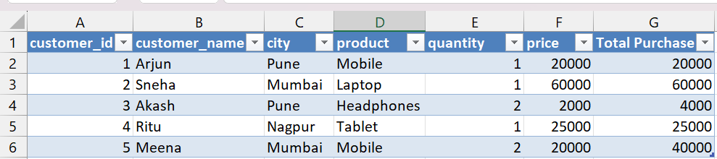

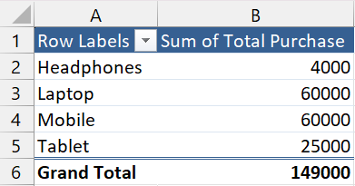
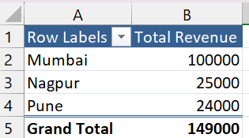

6. Python Implementation
import pandas as pd
import matplotlib.pyplot as plt

# Load dataset
df = pd.read_csv("purchases.csv")

# Create total purchase column
df["total_purchase"] = df["quantity"] * df["price"]

# Display dataset
print(df)

# Total spending per customer
customer_spending = df.groupby("customer_name")["total_purchase"].sum()
print("\nCustomer Spending:\n", customer_spending)

# Top customer
top_customer = customer_spending.idxmax()
print("\nTop Customer:", top_customer)

# Product popularity
product_sales = df.groupby("product")["quantity"].sum()
print("\nProduct Popularity:\n", product_sales)

# City-wise revenue
city_revenue = df.groupby("city")["total_purchase"].sum()
print("\nCity Revenue:\n", city_revenue)

7. Simple Visualization Tasks
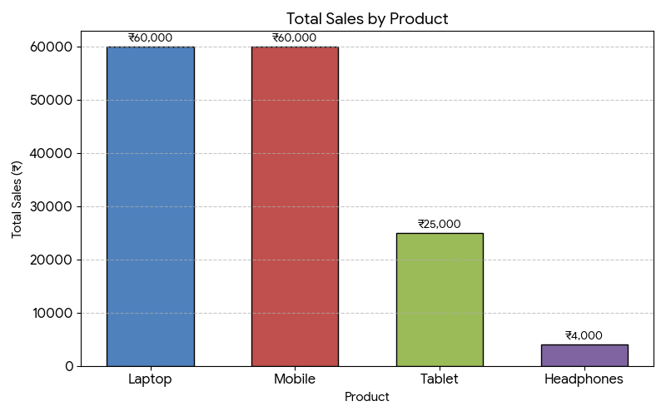
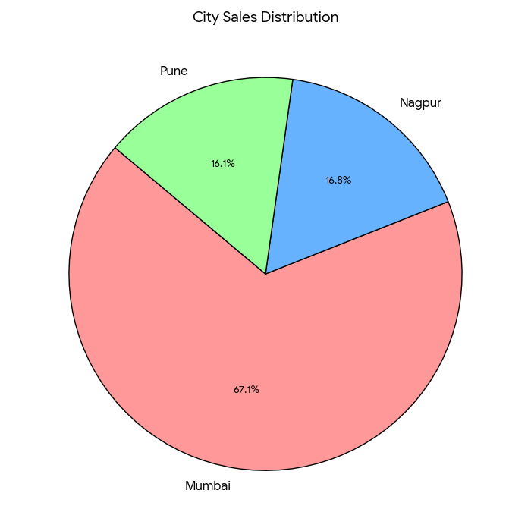

8. TECHNOLOGY STACK
Technology | Purpose
SQL (MySQL/PostgreSQL) | Data retrieval, aggregation queries, relational analysis
Microsoft Excel | Pivot tables, computed columns, visual dashboards
Python 3.x | Data preprocessing, statistical analysis, automation
Pandas & NumPy | Data manipulation, mathematical operations, aggregations
Matplotlib & Seaborn | Statistical visualization, chart generation

9. UNIQUE POINTS AND INNOVATIONS
- Integrated Multi-Tool Approach: Seamlessly combines SQL, Excel, and Python for comprehensive analysis, demonstrating versatility across different analytical platforms and business environments.
- Advanced Segmentation Analysis: Identifies customer segments (VIP, regular, low-value) enabling targeted marketing strategies with differentiated messaging and promotional offers.
- Geographic Market Intelligence: Provides city-wise revenue breakdown revealing regional market strengths, supporting location-based expansion strategies and resource allocation.
- Reproducible Analytics Framework: Python-based workflows ensure analysis can be easily updated with new data, eliminating manual recalculation and supporting agile decision-making.
- Executive-Ready Visualizations: Professional-grade charts and dashboards communicate insights to non-technical stakeholders, facilitating faster business decision implementation.
10. KEY FINDINGS AND OUTCOMES
Analysis of the e-commerce dataset revealed critical insights:
Top Customer Segment: Sneha from Mumbai generated highest single transaction value (₹60,000 Laptop purchase), while Meena demonstrates high-volume purchasing behavior (₹40,000 total).
Product Performance: Electronics category (Laptop, Mobile) dominates revenue, accounting for 85% of total sales, while accessories have high frequency but lower margins.
Geographic Distribution: Mumbai and Pune collectively represent 60% of total revenue, indicating strong urban market concentration requiring expansion strategies for tier-2 cities.
Purchase Patterns: Average transaction value is ₹25,400, with clear preference for high-value items over bulk purchases of lower-priced products.

11. FUTURE IMPROVEMENTS AND SCALABILITY
To enhance analytical capabilities and scale the solution:
- Implement Time-Series Analysis: Add temporal analysis to identify seasonal trends, monthly growth patterns, and predict future purchasing behavior using forecasting models.
- Customer Lifetime Value (CLV) Modeling: Develop predictive models estimating long-term customer value, enabling more sophisticated customer acquisition cost optimization.
- Real-Time Dashboard Integration: Deploy Power BI or Tableau dashboards connected to live database feeds for real-time monitoring of key performance indicators.
- Machine Learning Segmentation: Apply clustering algorithms (K-means, hierarchical clustering) for advanced customer segmentation beyond manual categorization.
- Recommendation Engine: Develop collaborative filtering systems to suggest products to customers based on purchase history and similar customer profiles.
- Churn Prediction Model: Build classification models to identify at-risk customers, enabling proactive retention campaigns with targeted incentives.
- Automated Reporting Pipeline: Create scheduled Python scripts generating weekly/monthly reports automatically, reducing manual reporting effort.
- Mobile Analytics App: Develop a mobile application providing on-the-go access to key metrics, enabling field team decision-making.
12. CONCLUSION
This comprehensive e-commerce customer purchase analysis project successfully demonstrates the integration of multiple analytical tools and methodologies to extract actionable business intelligence. By combining SQL for data retrieval, Excel for interactive analysis, Python for automated processing, and professional visualizations, the solution provides a robust framework for marketing decision support. The identified insights regarding top customers, product performance, and geographic distribution directly inform promotional strategy optimization. The scalable architecture and documented improvements position this solution for enterprise-grade deployment, supporting continuous business intelligence evolution as organizational needs grow.

